Project Design Phase
Solution Architecture

Date | 05 July 2026
Team ID | Solo Project – Individual Capstone
Project Name | Library Management System (ServiceNow)
Maximum Marks | 4 Marks

Solution Architecture:
Smart Library Request Workflow Architecture: (built on ServiceNow PDI: dev218155)
The diagram below reflects the actual configuration verified on the personal Developer Instance: the Book (u_book) and Borrow Request (u_borrow_request) tables, the Borrow Request Approval Flow in Flow Designer, and the Access Control rules on both tables.
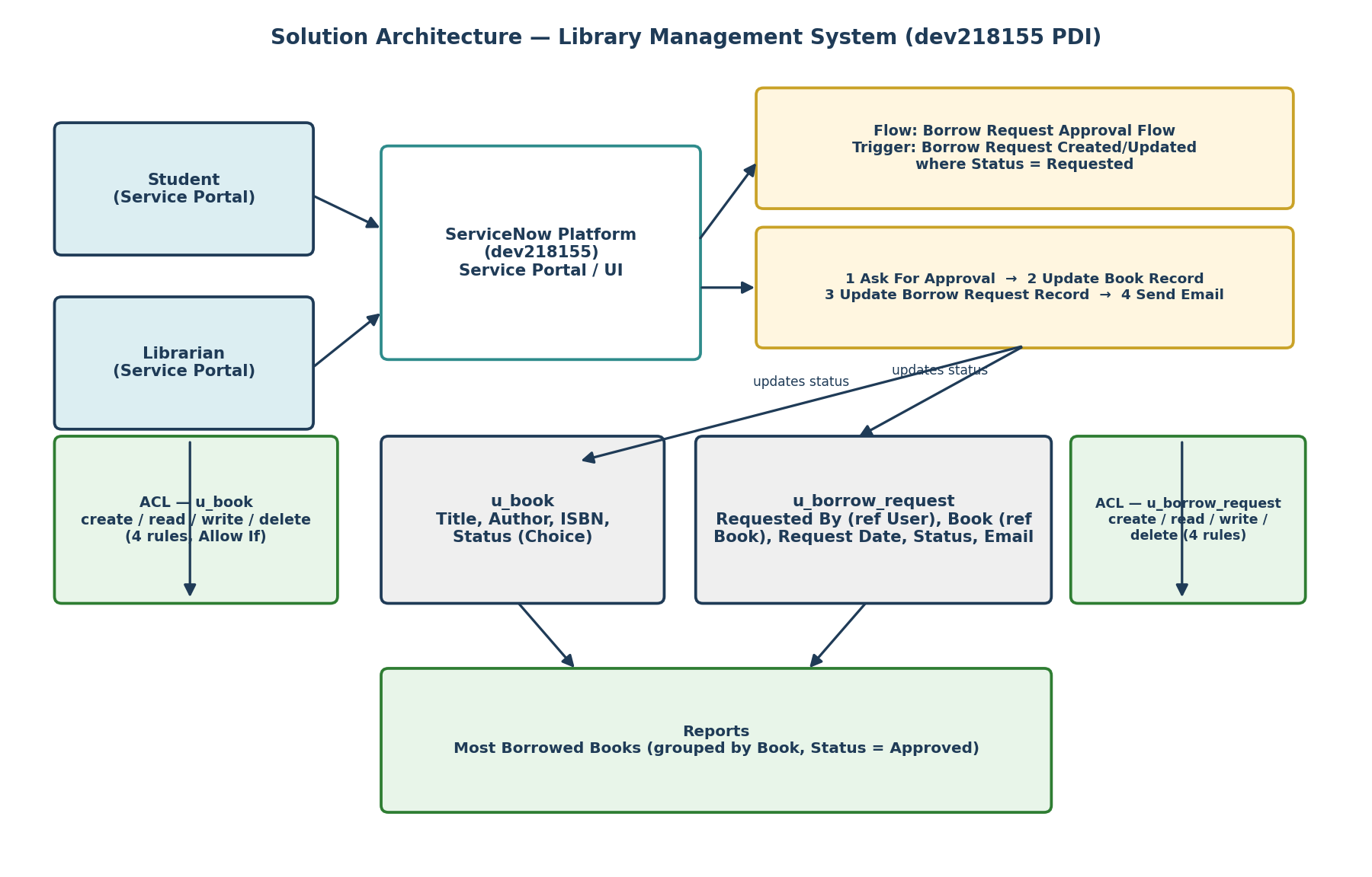

Table 1: Book (u_book) — Fields
Field | Type | Notes
Title | String | Book title
Author | String | Book author
ISBN | String | Book ISBN
Status | Choice | Available / Issued / Lost
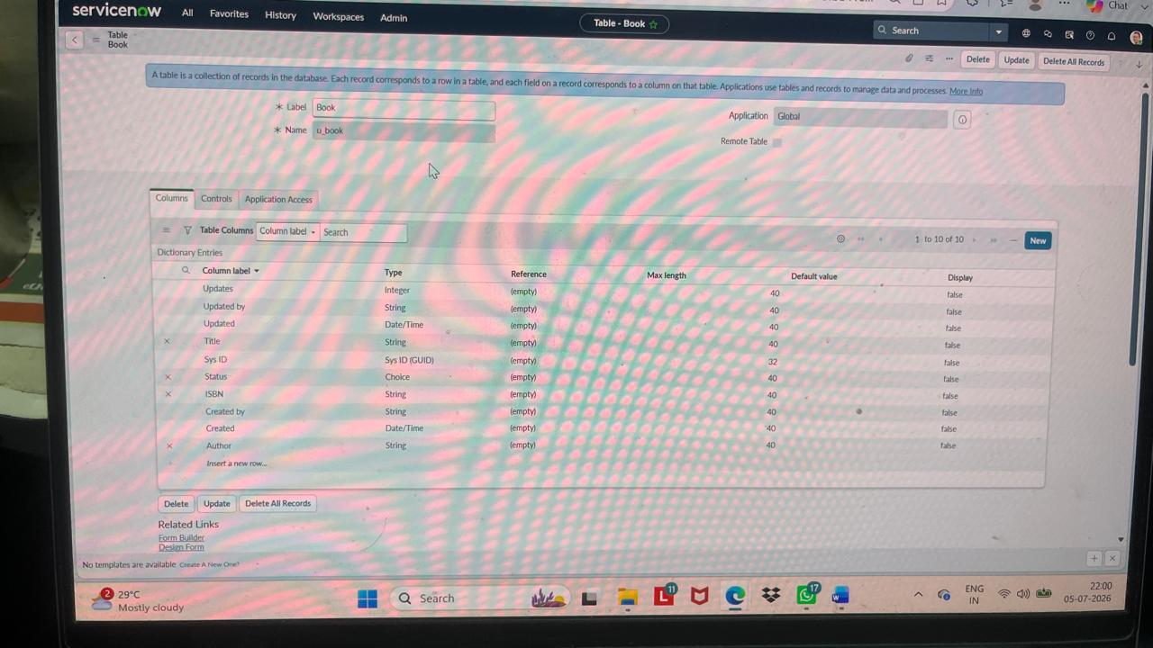

Table 2: Borrow Request (u_borrow_request) — Fields
Field | Type | Notes
Status | Choice | Requested / Approved / Rejected / Returned
Requested By | Reference (User) | Student who submitted the request
Email | String | Notification email captured for the request
Book | Reference (Book) | Book being requested
Request Date | Date/Time | Date/time the request was submitted
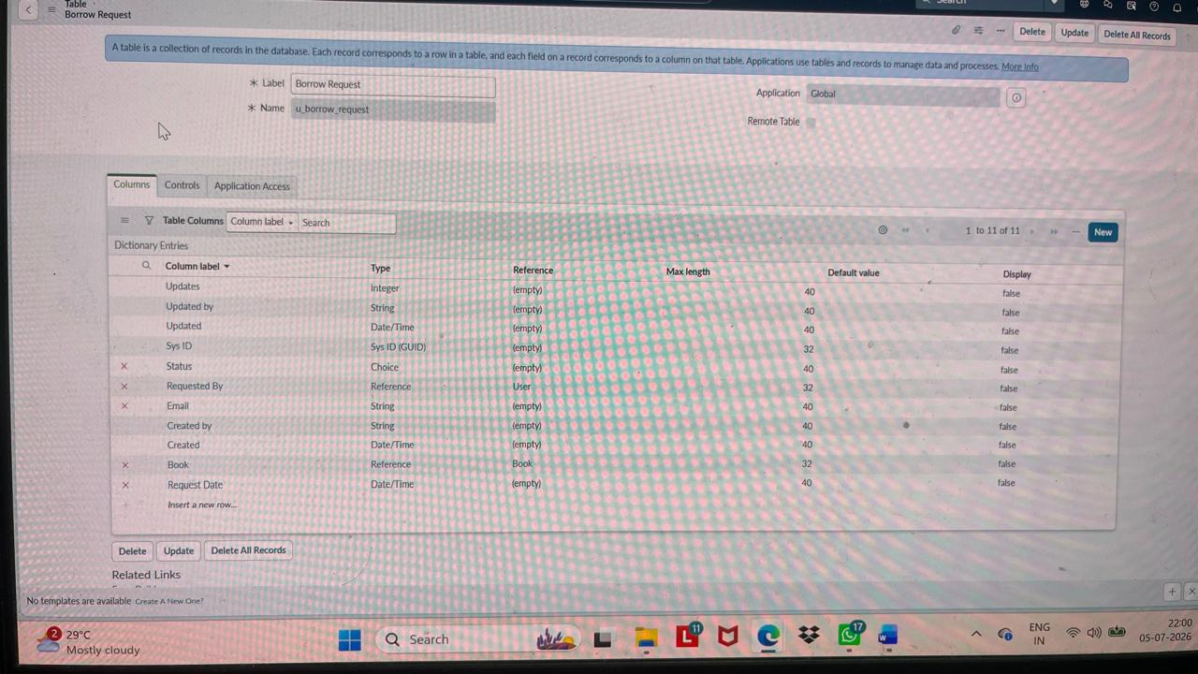

Table 3: Access Control (ACL) Summary
Table | Operation | Decision Type | Active
u_book | create | Allow If | true
u_book | read | Allow If | true
u_book | write | Allow If | true
u_book | delete | Allow If | true
u_borrow_request | create | Allow If | true
u_borrow_request | read | Allow If | true
u_borrow_request | write | Allow If | true
u_borrow_request | delete | Allow If | true
All 8 ACL rules were verified as Active (true) on both tables, each set to Allow If / record type.
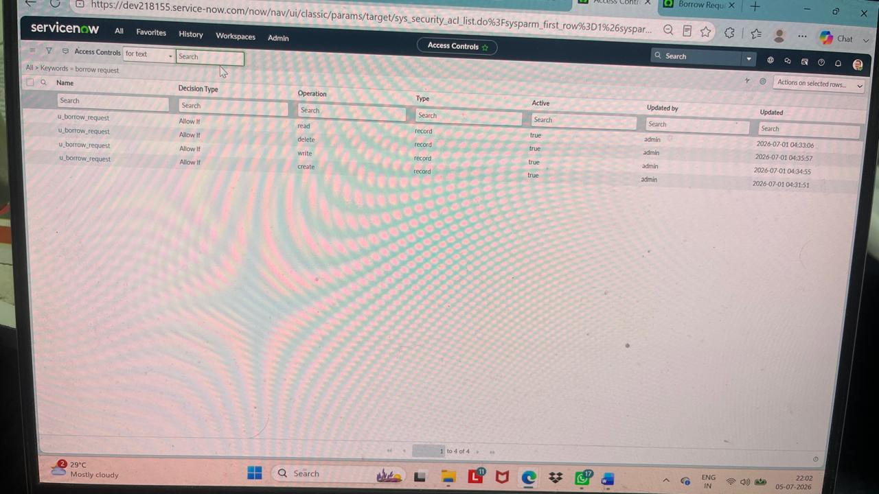
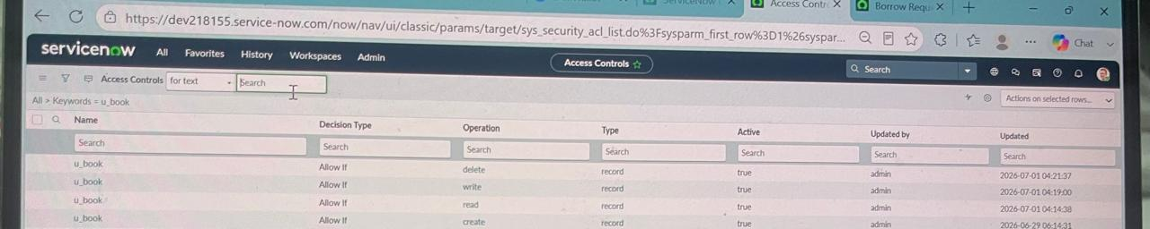
Borrow Request Approval Flow (Flow Designer)
Flow name: Borrow Request Approval Flow — Status: Active
Trigger: Borrow Request Created or Updated, where Status is Requested.
1. Ask For Approval on Borrow Request
2. Update Book Record
3. Update Borrow Request Record
4. Send Email
An Error Handler is present on the flow (currently inactive) to catch failures in any of the four actions above.
